Collin Ruggeberg, Luke Surowiec, and Nick Muratore 221L

In developing this project, the initial sign-in form was easy to complete using a combination of HTML, CSS, and JavaScript. The form looked very professional and featured a Sign-In form, as well as a Create Account form. The initial form, however, did not connect to any database and just cleared the entered forms when prompted to submit. 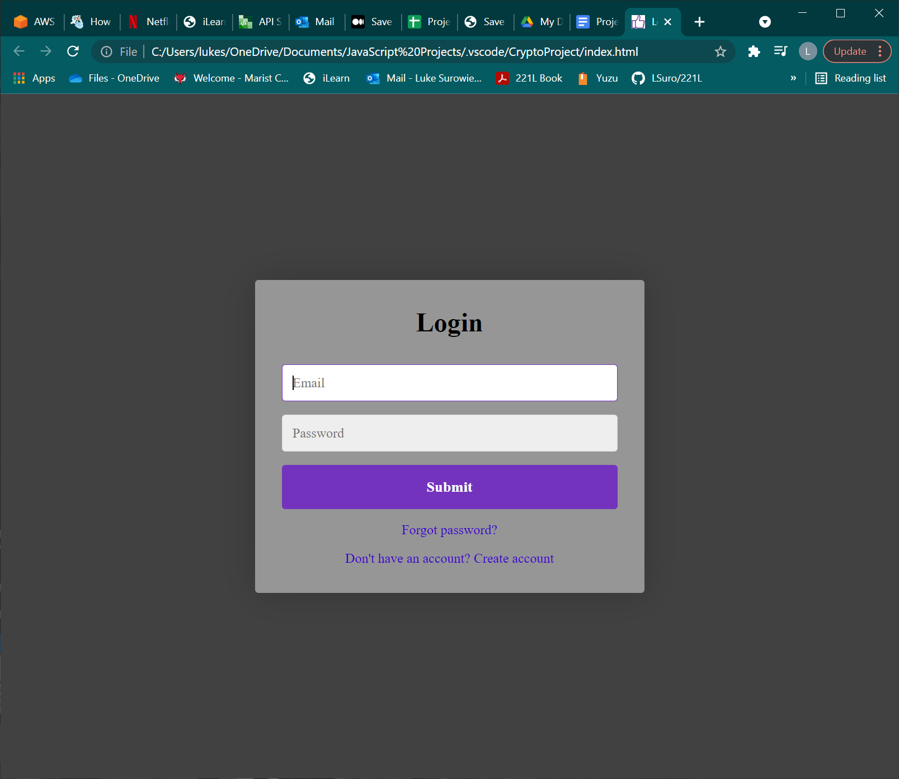

The next stage in development, then, was to attempt to add database compatibility to the existing framework we created in HTML, CSS, and JS. After much research, we developed a very simple and not fancy-looking at all, test file, that just added the data entered in 2 undecorated fields to a spreadsheet we desired. This form did efficiently work in the way we desired, adding the data to the test spreadsheet as the submit button was clicked. Our third step in this design process was to attempt to mesh the two designs together. We began slowly adding elements and removing elements to work on adding database functionality to our design, but we could not fully integrate it in the time given. In its current state, we have 3 programs 2 that work and one that is not fully working yet, all of its perspective pieces work, but the end goal of combining the two programs was not fully met. We are also going to be adding a password verification part to our code later.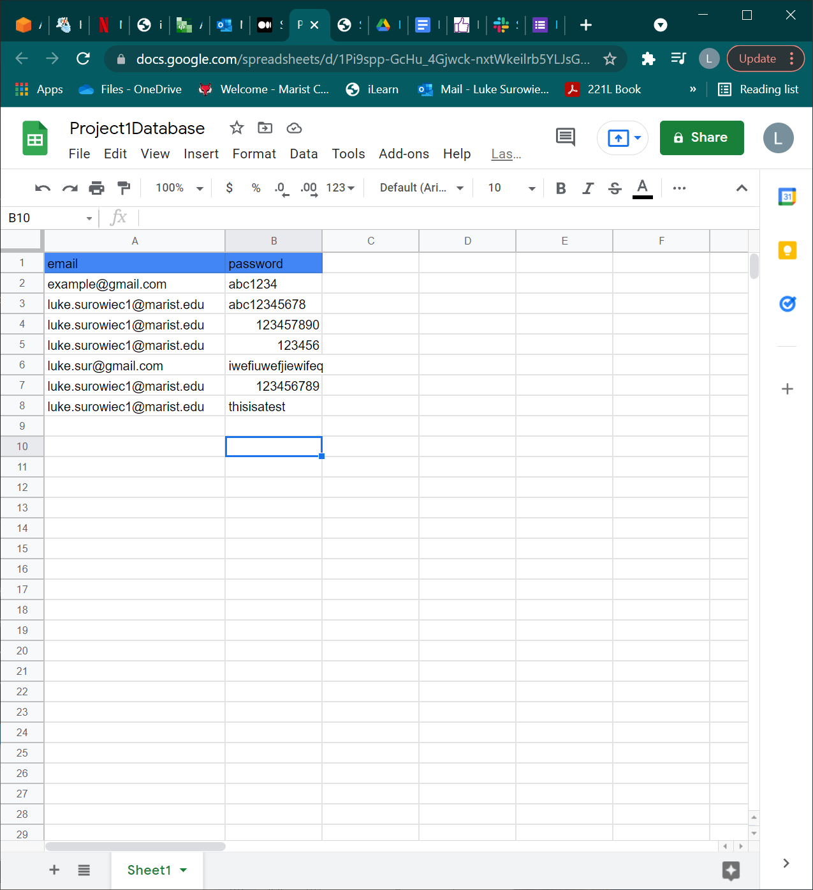

Images of Code: